Phishing Domain Detection

Wireframe Document

By: Akshay Kumar BM

Email: [akshaykumarbedre.bm@gmail.com](mailto:akshaykumarbedre.bm@gmail.com)

Home page:

Enter field:

* Url (string )

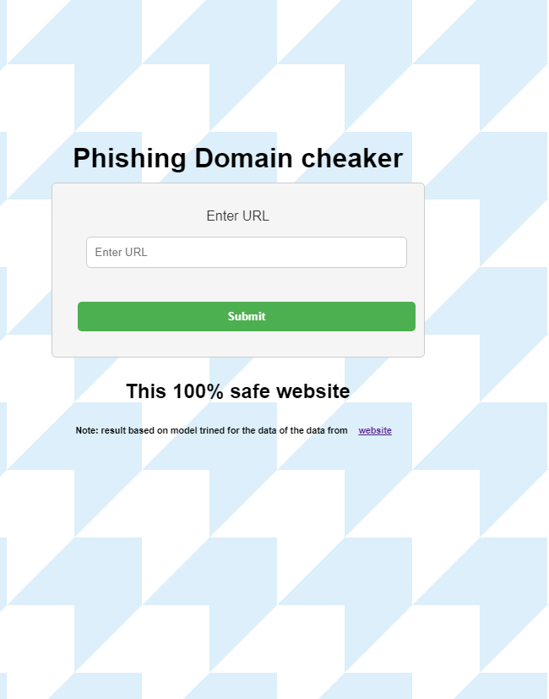

EX

Case 1:

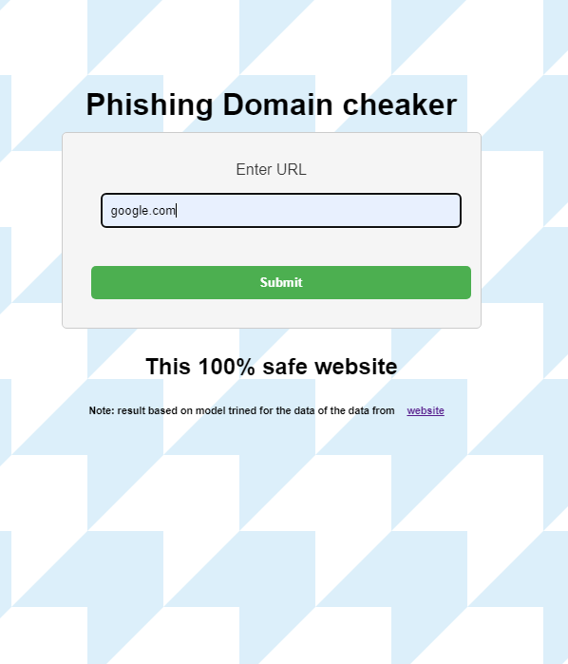

Case 2:

